**DBS PROJECT REPORT:**

FAREES FATIMA

SHAHREEN SHEIKH

PROJECT NAME : ONLINE SHOPPING/E-COMMERCE WEBSITE:

INTRODUCTION:

The E-Commerce Website Database Project aims to design and implement a robust database system to support the functionality of an e-commerce website. The project focuses on creating an efficient and secure database structure that can handle the dynamic nature of online retail operations. The database serves as the backbone for storing and managing product information, user data, transactions, and other essential elements required for seamless e-commerce operations.

Objectives and Goals:

1. Database Design: Develop a comprehensive database schema and entity-relationship model to represent the key components of the e-commerce website, including products, customers, orders, and transactions.

2. Normalization: Apply normalization techniques to ensure the database is organized efficiently, minimizing redundancy and dependency issues. Aim for a high level of normalization to enhance data integrity.

3. Data Security: Implement robust security measures to safeguard sensitive information. This includes user authentication, access controls, and encryption to protect customer and transaction data.

4. Data Manipulation: Implement CRUD (Create, Read, Update, Delete) operations to enable seamless interaction with the database. This includes defining and implementing stored procedures and triggers for efficient data manipulation.

5. Scalability: Design the database system with scalability in mind, anticipating future growth in terms of users, products, and transactions. Ensure that the database architecture can handle increased load and demands.

6. Testing: Conduct thorough testing of the database system to validate its functionality, performance, and security. Develop and execute test cases to identify and resolve any issues that may arise during different scenarios.

7. User-Friendly Interface: Integrate the database seamlessly with the front-end of the e-commerce website, providing a user-friendly interface for both customers and administrators. Ensure smooth navigation and responsiveness.

8. Documentation: Create comprehensive documentation for the database, including an entity-relationship diagram, data dictionary, and SQL scripts. Provide clear instructions for future maintenance and enhancements.

By achieving these objectives, the E-Commerce Website Database Project aims to contribute to the efficiency, reliability, and security of the e-commerce platform, ultimately enhancing the overall user experience for customers and facilitating the management of online retail operations.

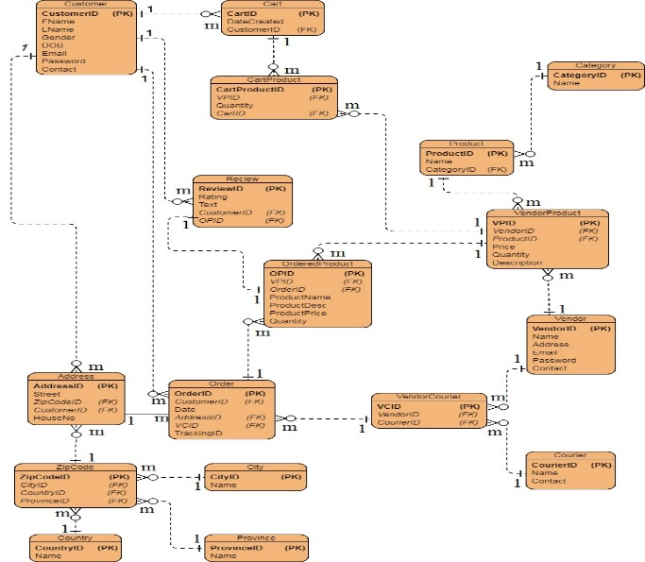

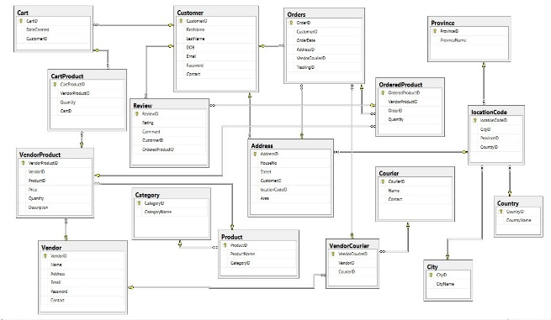

SOURCE CODE:













Conclusion:

The E-Commerce Website Database Project has reached its culmination, resulting in significant findings and achievements that contribute to the enhancement of the overall functionality and reliability of the e-commerce platform. Throughout the project lifecycle, various key aspects were addressed , leading to a more efficient and secure database system.

Key Findings and Achievements:

1. Database Efficiency: The implemented database schema and normalization techniques have significantly improved the efficiency of data storage and retrieval. The normalized structure ensures minimal redundancy and optimal data organization, contributing to enhanced performance.

2. Security Measures: The incorporation of robust security measures, including user authentication, access controls, and encryption, has fortified the database against potential threats. Sensitive customer and transaction data are now safeguarded , meeting industry standards for data security.

3. Scalability: The database architecture has been designed with scalability in mind. Through careful planning and implementation, the system can accommodate future growth in terms of users, products, and transactions without compromising performance.

4. Data Manipulation: The implementation of CRUD operations, stored procedures, and triggers has facilitated seamless data manipulation. Users can interact with the database efficiently, and administrators have the tools needed for effective management of the e-commerce platform.

5. Testing Success: Rigorous testing procedures have been executed, leading to the identification and resolution of potential issues. The database has proven its reliability and functionality under various scenarios, ensuring a stable and dependable platform.

Lessons Learned:

1. Importance of Robust Security: The project emphasized the critical role of robust security measures in protecting sensitive information. Future projects should prioritize security considerations from the outset.

2. Continuous Testing: Continuous and thorough testing is crucial for identifying and addressing issues promptly. A comprehensive testing strategy should be an integral part of the development process.

3. Scalability Planning: Anticipating future growth and planning for scalability is essential. The database architecture should be flexible enough to accommodate increasing demands without sacrificing performance.

4. Collaboration and Documentation: Effective collaboration among team members and comprehensive documentation are paramount. Clear documentation facilitates seamless knowledge transfer and future maintenance.

5. User Experience Considerations: User-friendliness of the database interface directly impacts the overall user experience. Incorporating feedback from end-users during the development process is crucial for creating an intuitive and user-friendly system.

In conclusion, the E-Commerce Website Database Project has not only achieved its defined objectives but has also provided valuable insights and lessons for future database projects.